Docker task 02

Create a tomcat container on 8080 and deploy sample application in tomcat.
`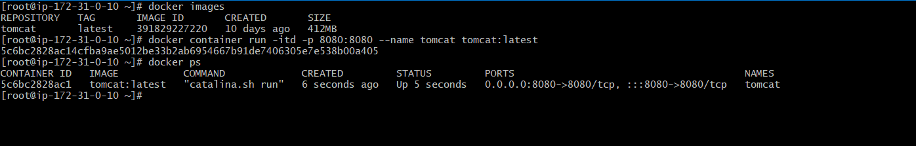
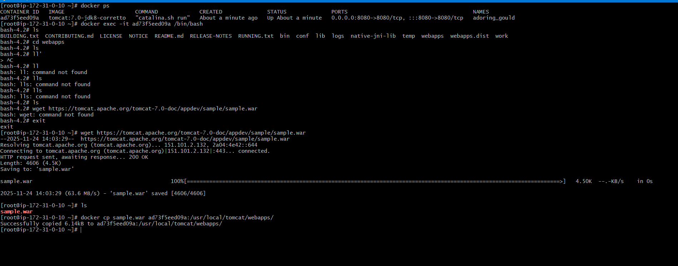
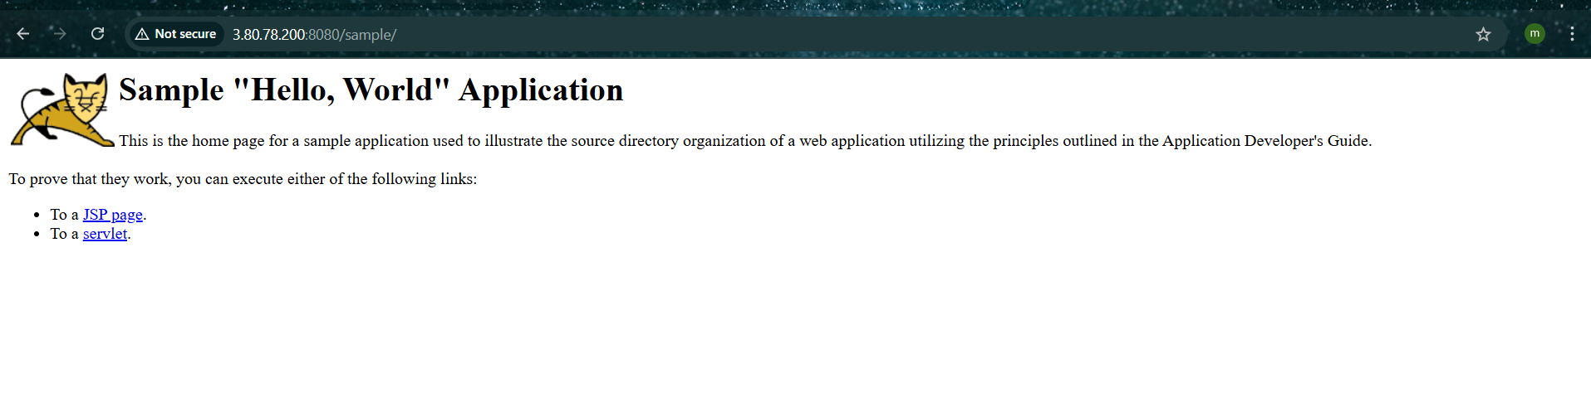

Create volume and deploy tomcat container on port 8081.
docker run -itd -p 8081:8080 -v /var/lib/docker/volumes/deployment:/usr/local/tomcat/webapps tomcat:7.0-jdk8-corretto

[root@ip-172-31-0-10 deployment]# wget https://tomcat.apache.org/tomcat-7.0-doc/appdev/sample/sample.war

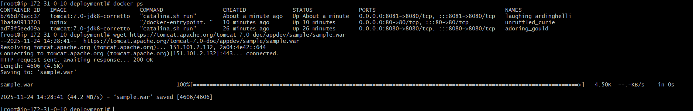
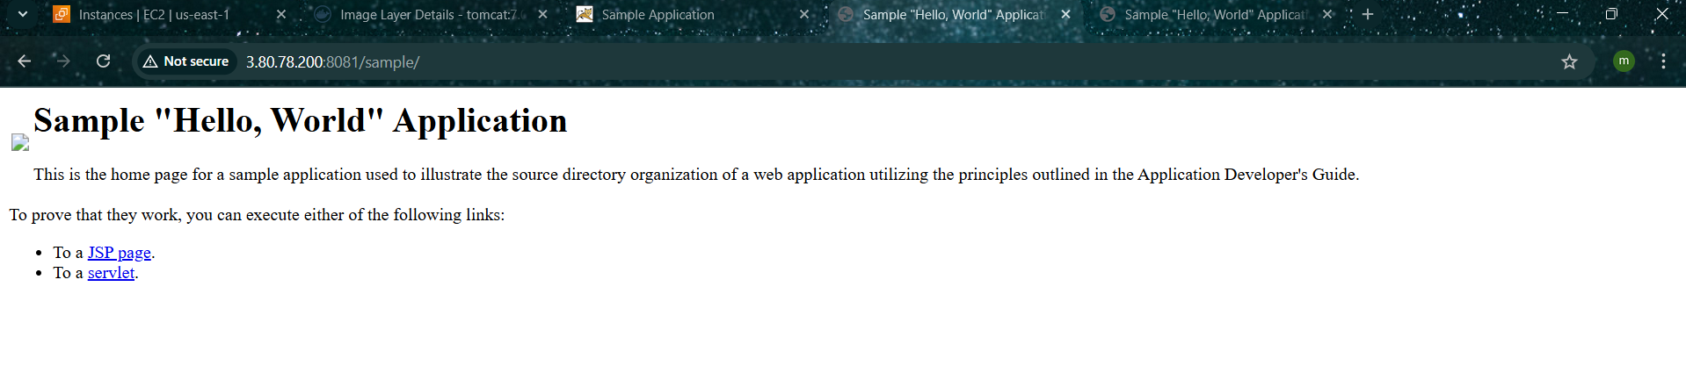
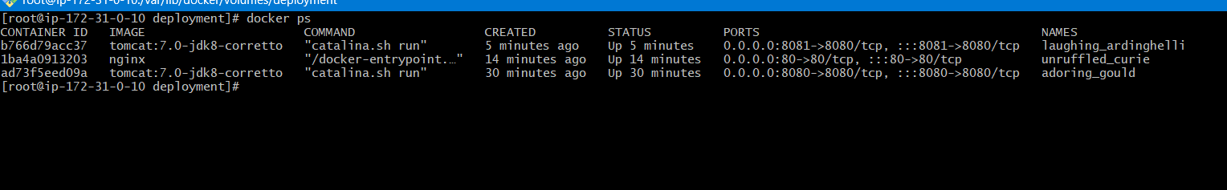

Limit the nginx container to 500 MB.
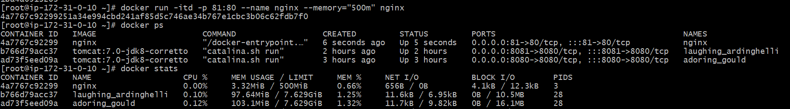

Create a sample docker file using below instructions.
Base module as amazonlinux:latest
Maintainer you name
Install nginx
COPY one index.html file to image
Expose on port 80
Command to start the nginx container
Push image to Docker hub
push image to AWS ECR

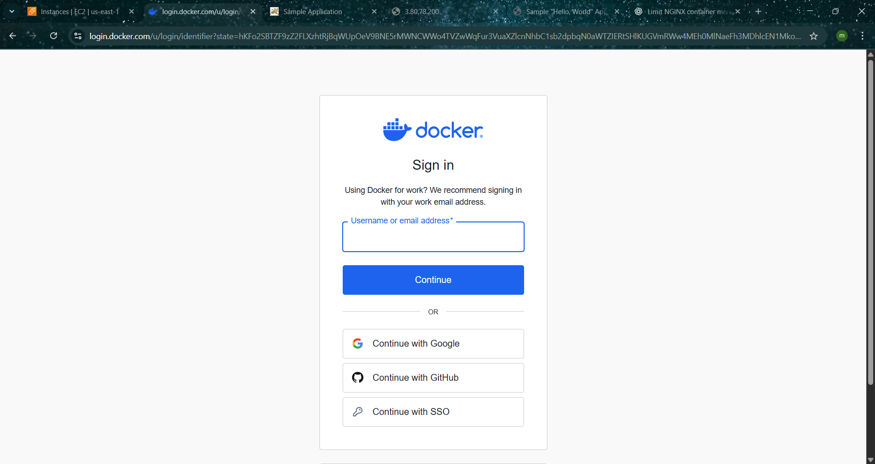
Create your docker hub account and login

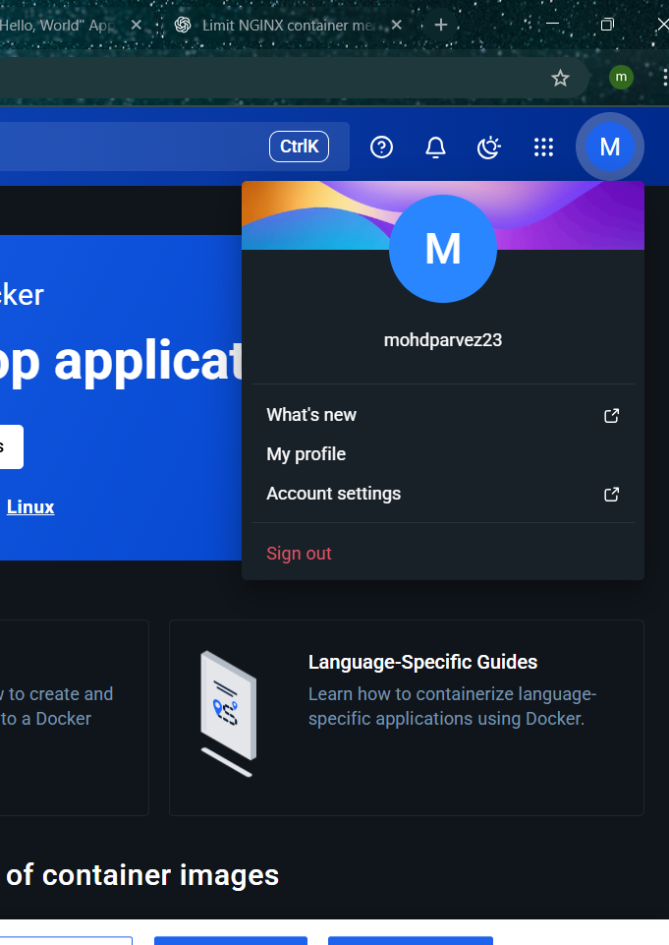
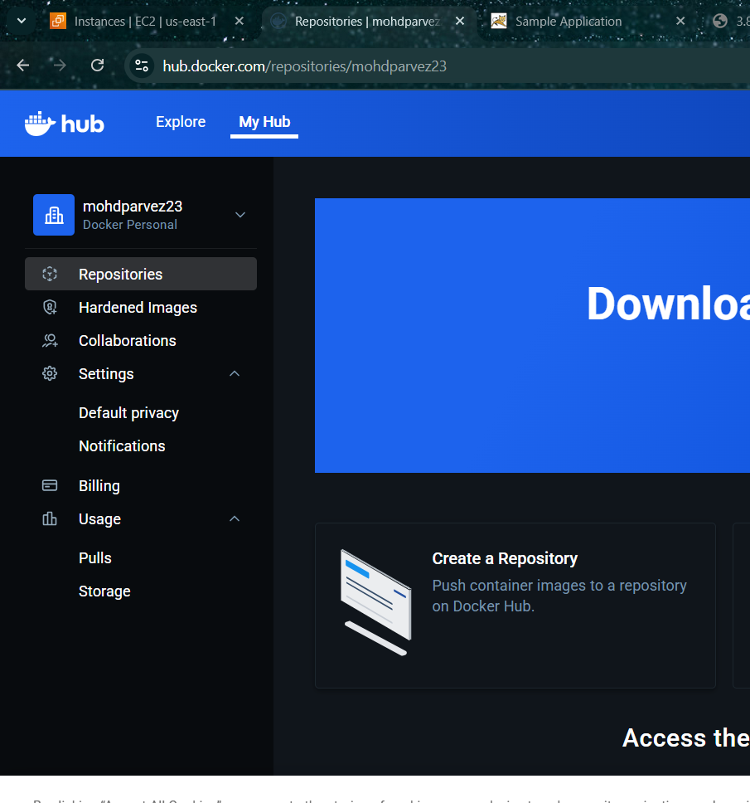
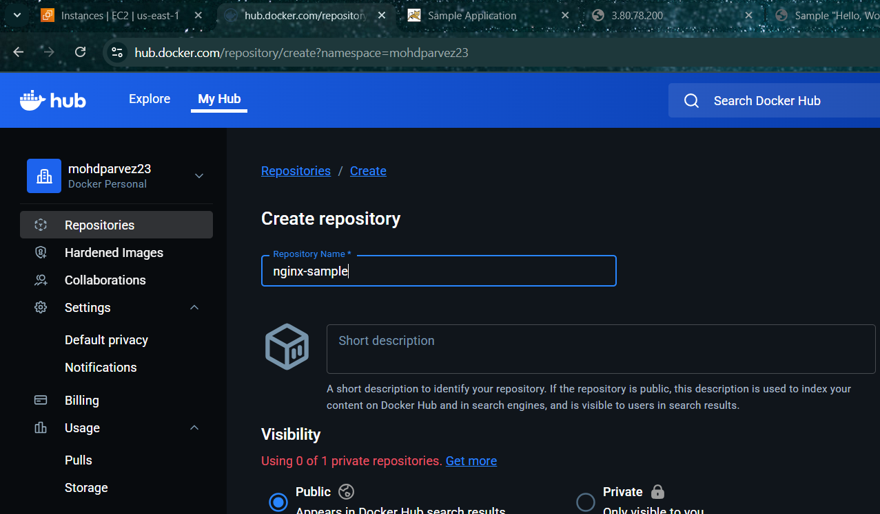
Login to your docker account using
Docker login
Provide your username and password you have created
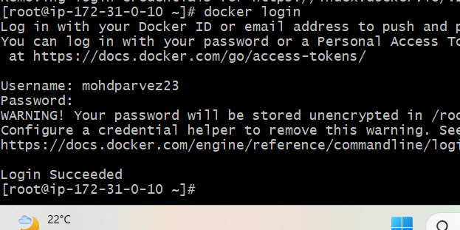
Create one directory and go to the directory
mkdir nginx-amazonlinux
cd nginx-amazonlinux
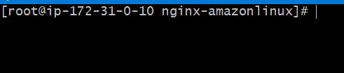
Create index.html file
cat > index.html <<'EOF'
<h1>Hello from amazonlinux nginx</h1>
EOF
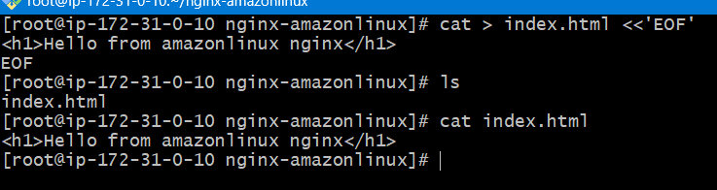

use a label for maintainer
create a docker file
cat > Dockerfile <<'EOF'
FROM amazonlinux:latest
LABEL maintainer="Mohd Parvez"

#install nginx (yum) and clean cache
RUN yum update -y && \
yum install -y nginx && \
yum clean all

# copy the single index.html into nginx html folder
COPY index.html /usr/share/nginx/html/index.html

#expose to port 80
EXPOSE 80

# run nginx in foreground
CMD ["nginx", "-g", "daemon off;"]
EOF
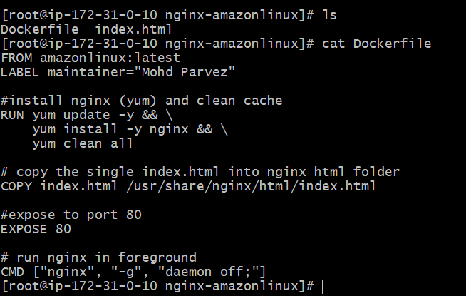
2. Build image
docker build -t my-nginx-amazonlinux:1.0 .
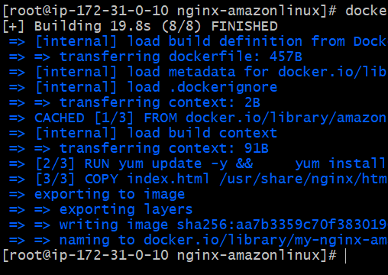
Run container (test locally)
docker run -d --name mynginx -p 80:80 my-nginx-amazonlinux:1.0
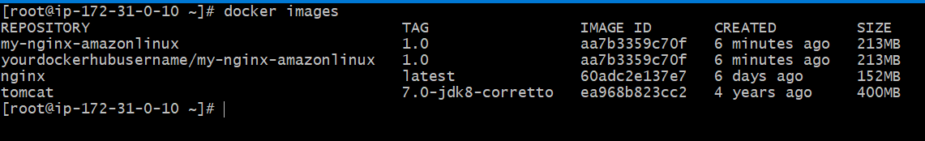
Push to Docker Hub
Login:
docker login

Tag:
docker tag my-nginx-amazonlinux:1.0 yourdockerhubusername/my-nginx-amazonlinux:1.0

Push:
docker push yourdockerhubusername/my-nginx-amazonlinux:1.0
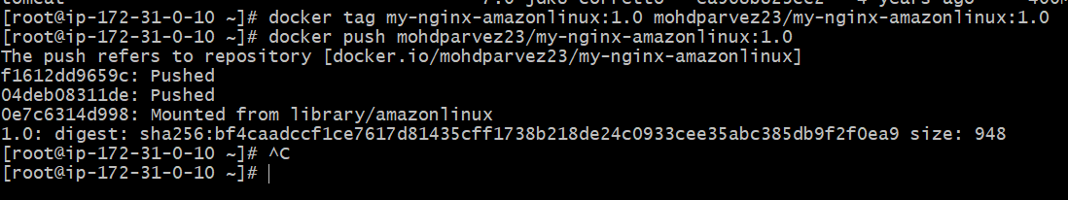
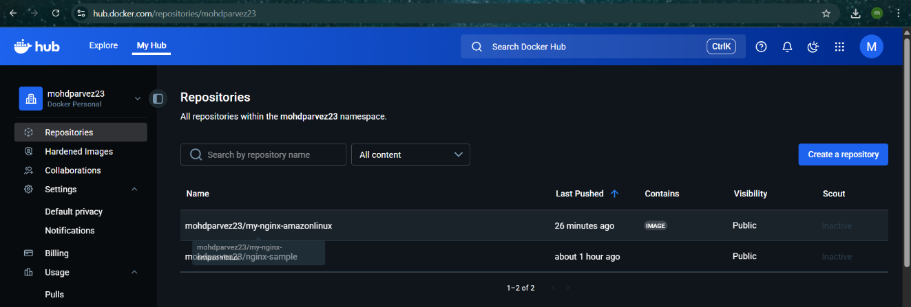

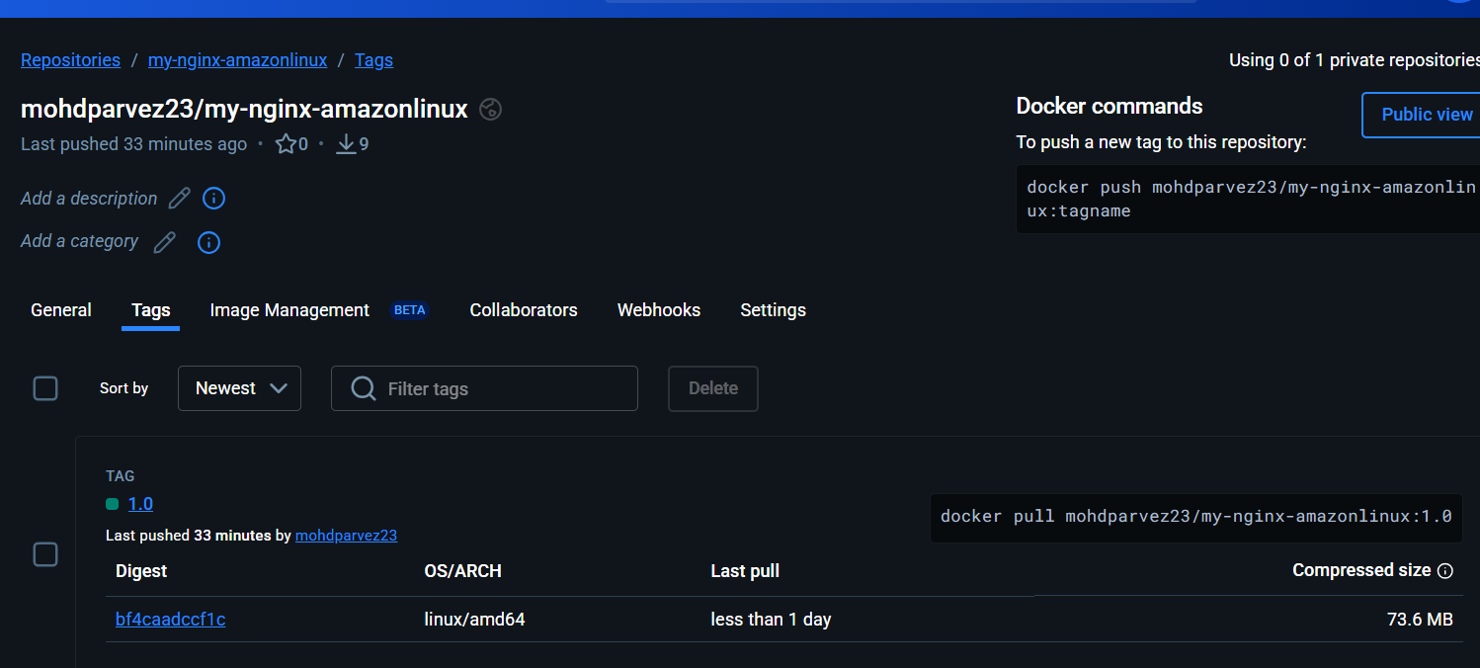

Push to AWS ECR (Git Bash)
Confirgure aws
Aws configure
Provide acess key and secret key
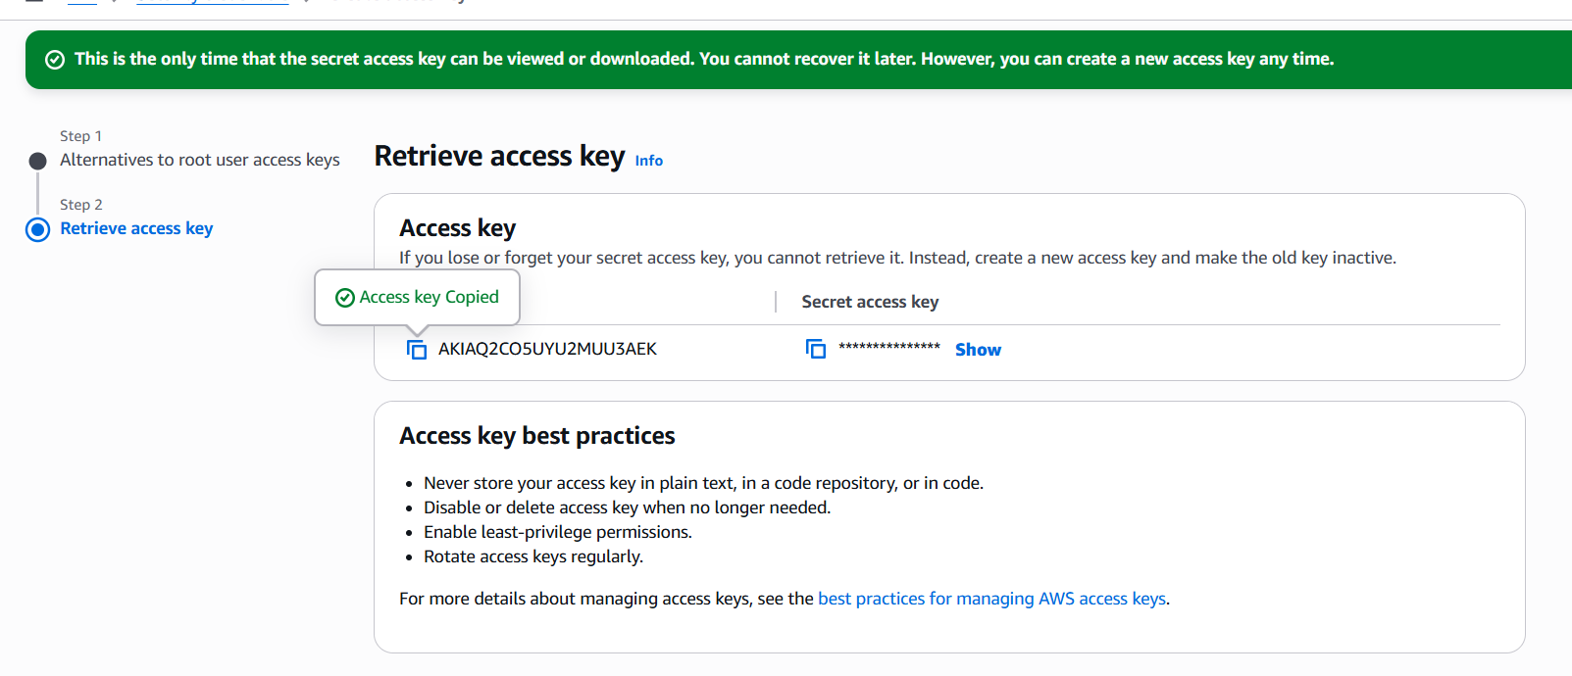
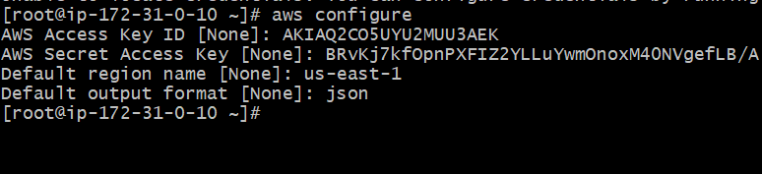
Replace:
AWS_ACCOUNT_ID

REGION
ECR_REPO

Create repo:
aws ecr create-repository --repository-name ECR_REPO --region REGION
aws ecr create-repository --repository-name first_repo --region us-east-1

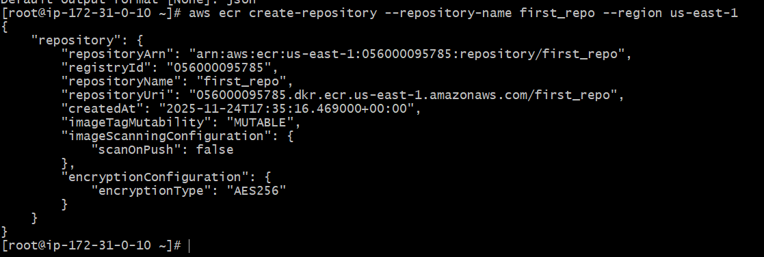
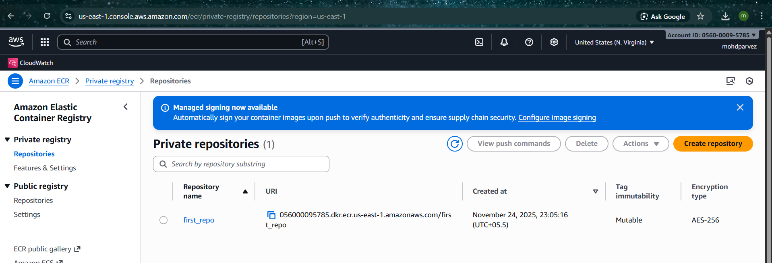
Run this command replace your url of ecr
#aws ecr get-login-password --region us-east-1 | docker login --username AWS --password-stdin “url ecr”

#aws ecr get-login-password --region us-east-1 | docker login --username AWS --password-stdin 056000095785.dkr.ecr.us-east-1.amazonaws.com/first_repo

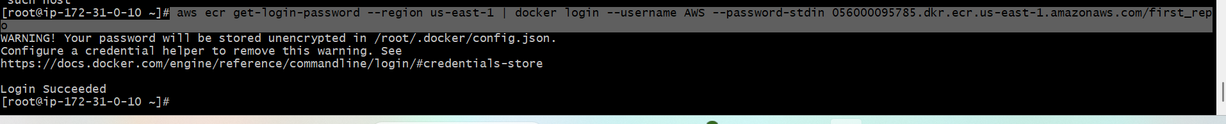

Tag image:
docker tag my-nginx-amazonlinux:1.0 \
AWS_ACCOUNT_ID.dkr.ecr.REGION.amazonaws.com/ECR_REPO:1.0
#docker tag my-nginx-amazonlinux:1.0 \
056000095785.dkr.ecr.us-east-1.amazonaws.com/first_repo:1.0
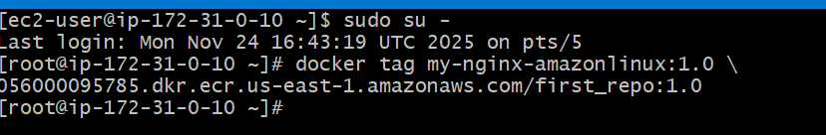
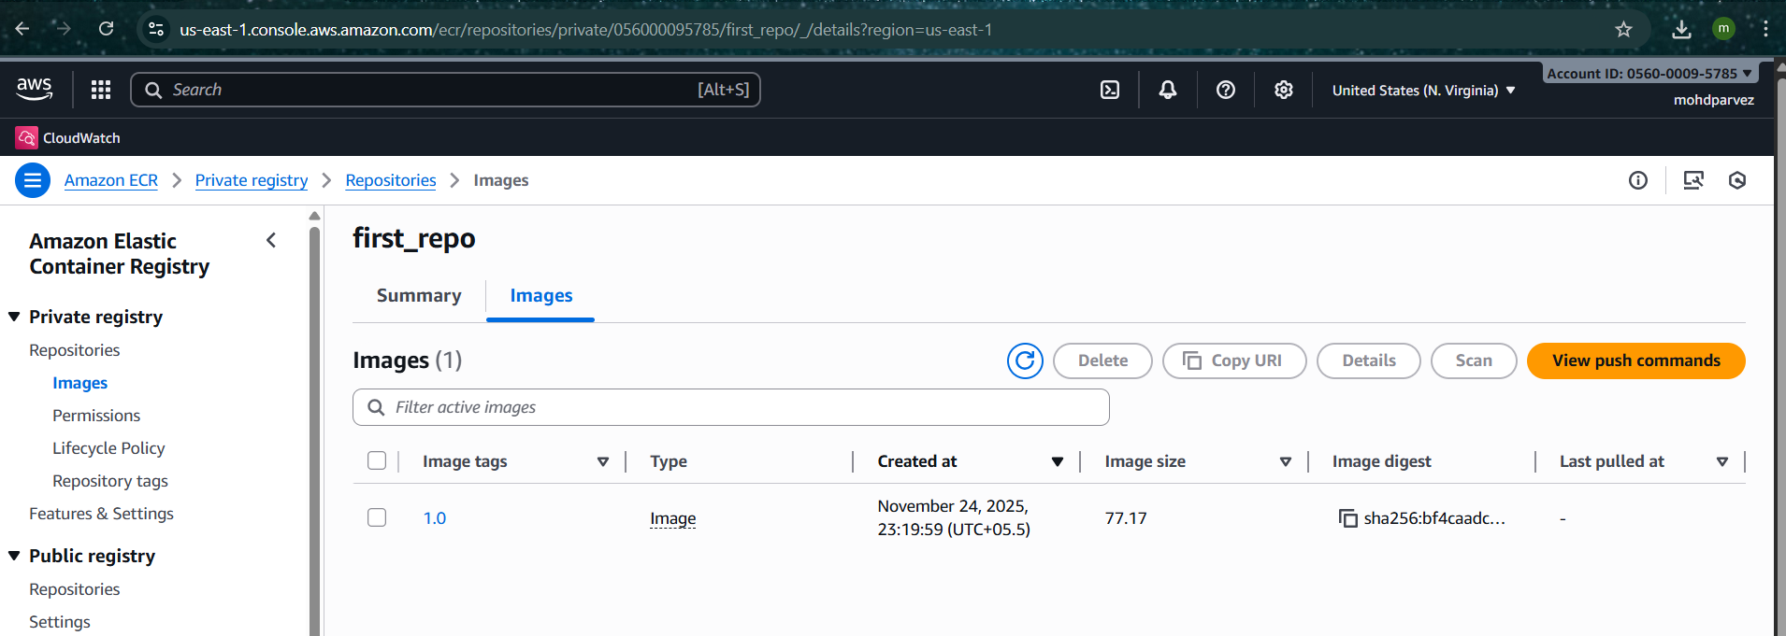
Push:
docker push AWS_ACCOUNT_ID.dkr.ecr.REGION.amazonaws.com/ECR_REPO:1.0

#docker push 056000095785.dkr.ecr.us-east-1.amazonaws.com/first_repo:1.0

